**Determination of the lactose content in milk by polarimetry**

**Introduction:**

Lactose is a disaccharide consisting of galactose and glucose, linked by a  1-4 glycosidic bond. It is the principal carbohydrate in the milk of all mammals. Milk contains only trace amounts of other sugars, including glucose, fructose, glucosamine, galactosamine, neuraminic acid and neutral and acidic oligosaccharides.

The concentration of lactose in milk varies widely between species. The lactose content of cows’ milk varies with the breed of cow, individuality factors, udder infection and especially stage of lactation. Mastitis depresses the secretion of lactose.

Lactose plays an important role in milk and milk products:

* it is an essential constituent in the production of fermented dairy products;
* it contributes to the nutritive value of milk and its products; however, many non-Europeans have limited or zero ability to digest lactose in adulthood, leading to a syndrome known as lactose intolerance;
* it affects the texture of certain concentrated and frozen products;
* it is involved in heat-induced changes in the colour and flavour of highly heated milk products.

**Principle:**

A polarimeter is used for determination of optical active substance in solutions.

A polarimeter consists of a pair of polarizers mounted in line, one of them can be rotated with respect to the other and the angle of rotation can be measured out on the scale. When both polarizers are crossed, what means that their polarising planes are mutually perpendicular, no light is passing through the instrument. As soon as an observation tube, filled with an optical active liquid, such as a sugar solution, is introduced in between the polarizers, the transmission of light is restored to a certain level. By rotation of one of the polarizers with respect to the other, the extinction of the light can be obtained again. The angle of this rotation is the measure of the optical activity of the solution in the observation tube in order to facilitate handling the optical system is set up in an angle of 20º.

1. 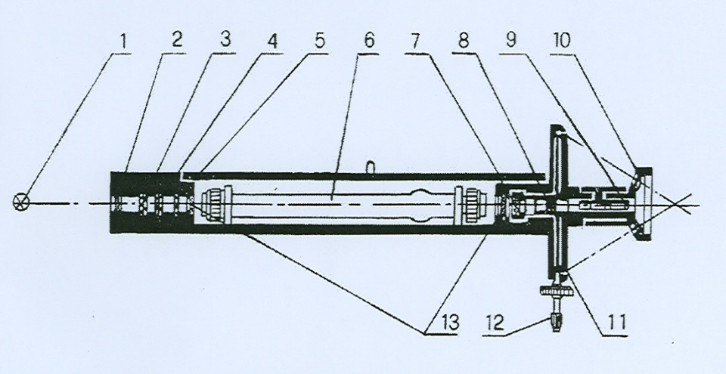Light source (sodium light)
2. Collector lens
3. Colour filter
4. Polarizer
5. Half-wave plate
6. Test tube
7. Polarization analyzer
8. Object lens
9. Eye lens
10. Magnifying glass
11. Dial vernier
12. Dial rotary hand-wheel
13. Protective plate

**Apparatus and equipment:**

Polarimeter, volumetric flasks, pipettes, beakers, funnels, filter paper.

**Chemicals and solutions:**

* potassium ferrocyanide K4[Fe(CN)6].3H2O solution (c = 150 g.l-1)
* zinc sulphate ZnSO4.7 H2O solution (c = 300 g.l-1)

**Procedure:**

* two parallel determinations
* weigh accurately 50 g of milk into a 100 ml volumetric flask,
* add 5 ml of K4[Fe(CN)6].3H2O and shake well,
* add 5 ml of ZnSO4.7 H2O solution and shake well,
* make the whole up to 100 ml with distilled water,
* mix again and allow the flask to stand at room temperature for 20 min,
* mix the content and filter through funnel with a fluted filter paper and collect the clear filtrate containing the lactose to be estimated,
* measure the optical activity (see below) of this solution (specific rotation – α) and calculate the lactose concentration of this solution, and hence of the original milk.

**Measuring the sample by polarimeter:**

1. Open the sample compartment

2. Filling the tube

- unscrew the cap near to the annular enlargement of the observation tube,

- take away the inner cap, the glass window and the gasket,

- fill the tube with the sample to be measured, keeping the tube well upright and maintaining it by the metal ring, to avoid any warming –up of the glass tube and the sample,

-fill the tube until the meniscus formed by the liquid of the sample stands on the top of the glass tube,

- slide the glass window over the top of the glass tube pushing the liquid forming the meniscus away,

-re-install the rubber gasket in the inner cap and push them together over the glass window

- screw the outer cap on,

- turn the complete observation tube into horizontal position.

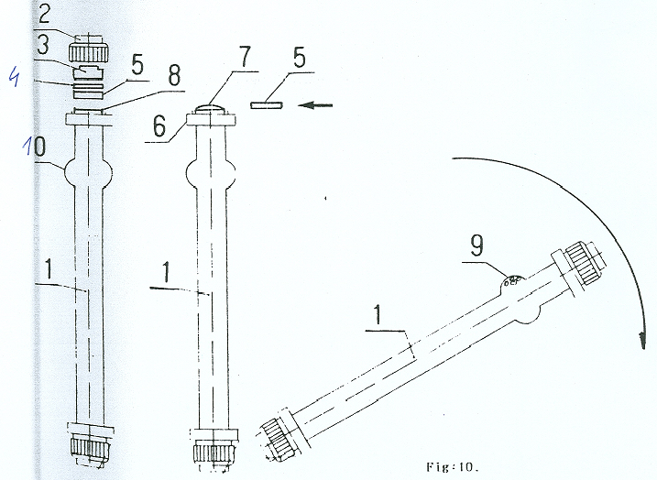- capture the eventual air bubbles into the annular enlargement before introducing the tube into the polarimeter’s sample compartment.

1. observation tube

2. cap

3. inner cap

4. gasket

5. glass window

6. annular enlargement

7. meniscus

8. glass tube

9. bubbles

10. annular enlargement

3. Introduce the tube into sample compartment taking care to maintain the air bubbles in the annular enlargement of the tube.

4. Close the sample compartments cover.

5. Observe the field through the eyepiece.

6. Rotate the scale control wheel until a uniformly illuminated field is obtained.



7. Read out the scale accurately using both verniers and the reading magnifiers in the eyeguard.

For example specific rotation   = 9.30

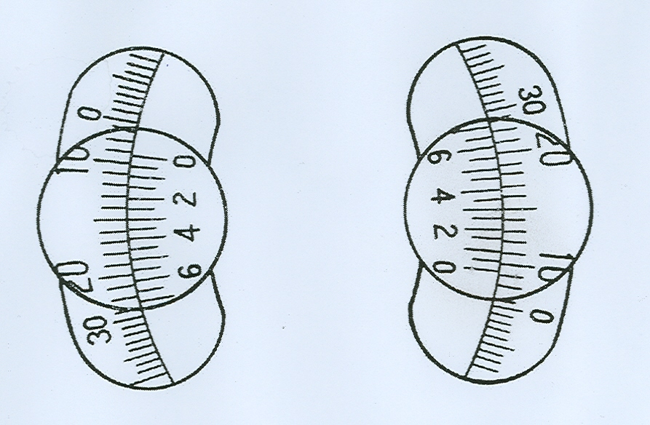

9.**3**

**9**.3

**Calculation:**

Lactose content is (g per 100 g milk = %) calculated by formula:

0.9518 × α × F

x = --------------------- × 100 [%]

a

x – concentration of lactose (%)

α – observed rotation

a – weight (g) of milk used

F – correction for coagulum – whole milk 0.954

– milk with 2% of fat 0.965

– skim milk 0.976

**Results:**

Content of lactose in milk is 4.6 - 4.9%.

**Determination of calcium content in milk by titrimetric method**

**Introduction:**

The mean calcium content of cows’ milk is 1 120 mg.l-1. In cows’ milk, calcium concentration is slightly elevated in colostrum and at the end of lactation but varies little with feeding or season. In cows’ milk, 99% of the calcium is in the skim milk fraction, which explains why the calcium content is not affected by fat removal. Cows’ milk and milk products, such as cheese and yoghurt, are very good sources of dietary calcium.

**Principle:**

This method belongs to titrimetric methods. Method uses ethylenediaminotetraacetic acid disodium salt (EDTA). The end point of the titration can be detected through a colour change. EDTA is a chemical reagent that forms strong and highly stable complexes with multivalent metallic ions in 1:1 ratio. EDTA titrations are applied to determine Ca, Mg and PO43-.

**Chemicals and solutions:**

* 0.01 mol.l-1 complexon III - ethylenediaminetetraacetic acid disodium salt solution (EDTA)
* indicator murexide
* 4 mol.l-1 sodium hydroxide (NaOH) solution

**Equipment:**

Burette, beakers, titration flasks, volumetric flasks, pipettes, graduated cylinder.

**Procedure:**

* two parallel determinations
* weigh 10 g of milk sample into volumetric flask (250 ml), make up to volume with distilled water and mix well,
* 50 ml of this diluted solution measure off with graduated cylinder into titration flask (250 ml),
* add 100 ml of distilled water,
* add 5 ml NaOH solution (c = 4 mol.l-1),
* add 0.2 g of indicator murexid,
* titrate with 0.01 mol.l-1 complexon III to the violet-blue colour.
* The same procedure is used for blank sample (instead of milk is used distilled water).
* Comparative sample (the same preparation as blank sample and moreover add 10 ml of complexon III.) The colour of this solution is the colour that marks the end of titration.

*!!!!Remark: First prepare comparative and blank samples, than the samples with milk.*

**Calculation:**

Calcium content is (mg per 100 g milk) calculated by formula:

(a - b) × 0.4 × 100 × V

x = ------------------------------------

m × V1

x – calcium content (mg per 100 g milk)

a – sample titre

b – blank titre

m – weight of sample

V – dilution of milk sample (= 250 ml)

V1 – volume of diluted sample solution which is used for titration (= 50 ml)

**Results:**

Recommended value of Ca content in milk by Czech standard is 1.2 g.l-1.

**Practical determination of chloride ions in milk**

**Introduction:**

Chloride is the principal extracellular anion and is essential in the maintenance of fluid and electrolyte balance. The chloride concentration in milk decreases from colostrum to mature milk but increases sharply towards the end of lactation and is independent of dietary intake. The chloride concentration increases during the mastitis.

**Principle:**

The principle of the detection of chloride ions is based on the precipitation of chloride by the excess of 0.1 mol.l-1 silver nitrate (AgNO3). Free AgNO3 is titrated by ammonium thiocyanate (NH4SCN). Sulphate ferric ammonium (FeNH4(SO4)2.12 H2O) is used as an indicator. Chloride content is calculated from AgNO3 content which was used for the precipitation of chloride.

**Equipment:**

Burette, beakers, titration flasks, pipettes.

**Chemicals and solutions:**

* 25% nitric acid (HNO3)
* 0.1 mol.l-1 silver nitrate solution (AgNO3)
* 0.1 mol.l-1 ammonium thiocyanate solution (NH4SCN)
* ammonium ferric sulphate FeNH4(SO4)2.12 H2O - indicator

**Procedure:**

* two parallel determinations
* fill the burette with 0.1 mol.l-1 NH4SCN solution up to zero level,
* weight 10 g of milk in titration flask (volume of 100 ml),
* add 5 ml of 25% HNO3,
* add 1 ml of indicator FeNH4(SO4)2.12 H2O,
* mix well,
* add 10 ml of 0.1 mol.l-1 AgNO3 solution into a titration flask,
* titrate with 0.1 mol.l-1 NH4 SCN solution until mixture turns permanent lightly red-brown colour.

**Calculation:**

Chloride content is (mg per 100 g milk) calculated by formula:

(10 – b) × 3.546 × 100

x = -----------------------------------------------

a

x – chloride content (mg per 100 g milk)

a – weight of the milk (g)

b – amount of NH4SCN solution (ml) used for titration

10 – ml of c (AgNO3) 0.1 mol.l-1

3.546 – mg Cl = 1ml 0.1 mol.l-1 AgNO3

*Conversion from % to g/l*: 97 ml = 100 g

**Results**

Content of chlorides in milk is in the range 89 - 127 mg.100 ml-1.

Content of chlorides in mastitis milk is > than 140 mg.100 ml-1.

**Calculation of chlorine - sugar number**

**Introduction**

Mastitis is an inflammation of the mammary gland caused most commonly by mastitis – causing organisms and rarely physical or chemical trauma, characterized by pathological changes in the mammary tissue, an increase in the number of somatic cells, physical, chemical and microbiological changes in the milk. This includes changes to the chemical composition of milk and because different milk components have different functional properties, this leads to changes in the processing properties of the milk. In the dairy cattle population both clinical and sub-clinical mastitis can affect the composition and manufacturing properties of milk.

Mastitis caused an increased level of NaCl in milk and depresses the secretion of lactose. Lactose, along with sodium, potassium and chloride ions, plays a major role in maintaining the osmotic pressure in the mammary system. Thus, any increase or decrease in lactose content (a secreted constituent, i.e. formed within the mammary gland) is compensated for by an increase or decrease in the soluble salt (excreted) constituents.

**Principle**

It is a ratio between chloride content (mg per 100 g of milk) and lactose content (g per 1000 ml of milk).

**Procedure**

* determination of lactose content
* determination of chloride content
* calculation the chlorine sugar number according to this formula:

**Formula**

Cl (mg per 100 g milk)

X= ---------------------------------------

lactose (g per 1 liter milk)

*Conversion from % to g/l*: 97 ml = 100 g

**Results**

The chlorine sugar number is between 1.7 - 2.2 in milk of healthy cow (bulk milk sample or milk sample from more than 5 cows), 1.2 – 2.5 in the milk sample of the individual cow or small group of animals, if its value is higher (2.5 – 6), the secretion disorders may be observed in the mammary gland.

**Literature**

Fox, PF., McSweeney, PLH. Dairy chemistry and biochemistry. Blackie Academic & Professional, an imprint of Chapman & Hall, London UK, 1998, 478 p.

NAVRÁTILOVÁ, P., DRAČKOVÁ, M. *Practical excercises from milk production hygiene*. Multimedia Teaching Text. 2009, 108 p.

Roginski, H., FUQUAY, JW., Fox, PF. Encyclopedia of dairy sciences. Vol. 1-4. Academic Press, London UK, 2003, 2777 p.

Instruction manual Polarimeter model PL 1. Optech, Optical technology. 9 p.

Instruction manual for p 1000 Polarimeter. A.Krüss optronic, 15 p.

1. Light source (sodium light)
2. Collector lens
3. Colour filter
4. Polarizer
5. Half-wave plate
6. Test tube
7. Polarization analyzer
8. Object lens
9. Eye lens
10. Magnifying glass
11. Dial vernier
12. Dial rotary hand-wheel
13. Protective plate



1. observation tube

2. cap

3. inner cap

4. gasket

5. glass window

6. annular enlargement

7. meniscus

8. glass tube

9. bubbles

10. annular enlargement

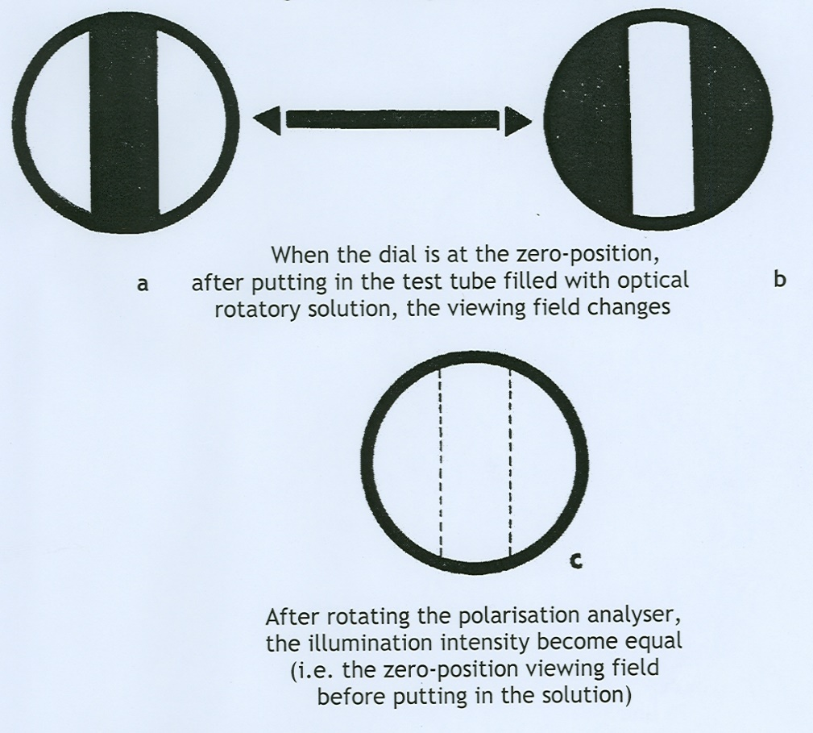

For example specific rotation   = 9.30



9.**3**

**9**.3