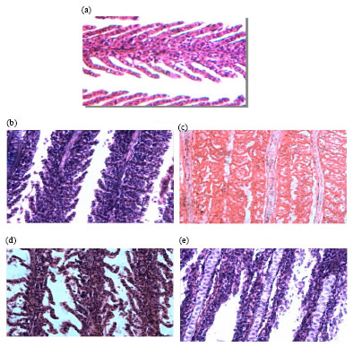

Transverse section of gills of fish *Cyprinus carpio* var.*Communis* exposed to acute ammonia concentration for 96 h. (Magnification X 400), (a) control, (b) after 24 h as ammonia exposure, (c) after 48 h as ammonia exposure, (d) after 72 h as ammonia exposure and (e) after 96 h as ammonia exposure

http://docsdrive.com/images/academicjournals/ajava/2012/fig1-2k12-588-596.jpg